**OBJECTIVES**

By the end of this module, you should be able to:

* Recognize information problems
* Understand how a decision‐maker’s view of uncertainty is different from a scientist’s view of uncertainty
* Solve a simple expected value of information problem

**INFORMATION PROBLEMS ARE COMMON**

In an information problem, a decision maker has to make a decision in the face of epistemic uncertainty, and wants to know whether it’s worth reducing that uncertainty before making the decision. This sounds fairly specific, but it’s actually a very common situation; sometimes it just masquerades as something else.

* Procrastination or delay. Often a decision maker will just delay a decision. Sometimes this is quite rational, because there is information that will develop in the interim that will be helpful and the costs of waiting are small. But note that this is a fairly precise calculation. There can be abuse of this approach, of course. It’s common enough to claim something is an information problem, but really the goal is just to avoid making a decision, or to wait for a controversy to blow over.
* Monitoring design and investment. Often, a natural resource management agency or office will seek advice in monitoring design, presenting it, perhaps, as a trade‐off decision about power of detection vs. cost and other considerations. But, in reality there is another hidden decision context, the one that concerns what you’ll do with the monitoring information once you have it. Presumably, the monitoring information might change the action you would choose in some other context.
* Identification of research needs. Natural resource management agencies often develop and prioritize lists of research needs. These are uncertainties that are valuable to reduce, presumably because they would improve the selection of management alternatives in some decision contexts. These decision contexts should be discussed before the list of research needs is generated, but this if often not the case.
* Adaptive management. In dynamic decisions, as we’ll discuss in Module 13, there is often an embedded information problem. Can a monitoring system provide early insights about our management interventions to allow us to improve later decisions?

**INFORMATION FROM A DECISION‐MAKER’S STANDPOINT**

Scientists love information. Their purpose is to pursue information for its own sake. But for a decision maker, *information is only ever a means objective*. For a decision maker, there is one important question:

*Will the information help me make a better decision?*

There are many cases where gathering information can help you make a more precise prediction about the outcomes of the different alternatives, but it won’t change the ranking of those alternatives. In other words, the information does not change the action the decision maker would choose.

There is a more subtle case, where the information might improve predictions, and might change the ranking of the alternatives, but the gain in the achievement of the objectives is expected to be fairly small. Here, the decision maker might decide that the costs of acquiring the information outweigh the benefits.

When decision makers balk at proposals for expensive and complex monitoring or research, they might actually be making very rational assessments of the value of information.

**WHERE DOES EPISTEMIC UNCERTAINTY COME FROM?**

Epistemic uncertainty represents the limits of our knowledge—it is uncertainty that is theoretically knowable, but not yet in our grasp. It arises both from empirical analyses and expert judgment processes. It is often represented in two forms: parametric uncertainty and structural uncertainty.

***Parametric Uncertainty***

* Genesis
* Sampling error
* Subjective judgment
* Expressed as
* Standard deviation
* Confidence (or credible) interval
* Probability distribution of parameters
* Special issues
* Bias
* Example
* Runge et al. (2009) estimated the intrinsic growth rate of a black vulture population as part of an effort to determine allowable levels of take. There was significant uncertainty in the estimate of the growth rate, which was represented with a probability distribution.

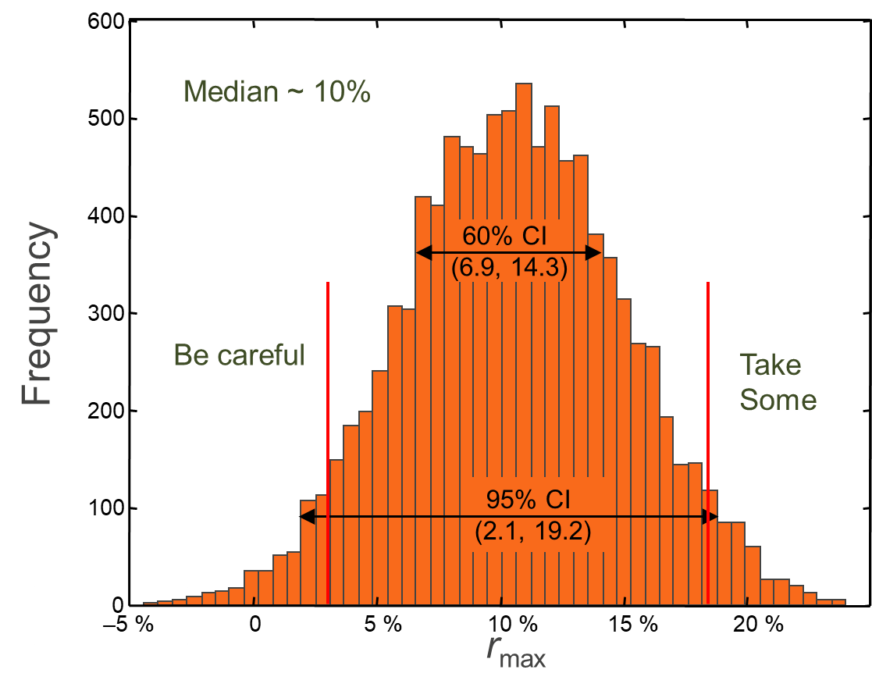

***Structural Uncertainty***

* Genesis
* Alternative ecological hypotheses
* Different stakeholder preferences
* Different intuitive experience (subjective judgment may be involved here as well)
* Expressed as
* Alternative models
* Special issues
* Weights associated with the alternative models
* Example
* Runge et al. (2011) articulated a range of hypotheses for the breeding failure of reintroduced whooping cranes in Wisconsin. The likelihood of each of these nine hypotheses was estimated through a formal process of expert judgment.
* The reintroduced parents are currently too young (9.4% weight of evidence)
* Black flies are causing parents to abandon nests (29.1%)
* Improper social conditioning in captivity leads to poor bonding with the nest (11.9%)
* Nutrient limitation on the breeding grounds (22.8%)
* Nutrient limitation on the wintering grounds (5.9%)
* Nutrient limitation on both the breeding and wintering grounds (6.6%)
* Egg salvage by humans because of apparent abandonment
* Human disturbance of the breeding environment (10.0%)

**EXPECTED VALUE OF INFORMATION**

There is a key tool from the decision analysis toolbox for evaluating the importance of reducing uncertainty. Called the *expected value of information*, it allows a calculation of how much the expected performance would improve if you could resolve uncertainty before choosing an action.

***Demonstration***

This example is modeled after Bogich and Shea (2008). You are losing revenue to gypsy moth infestation in your managed forest. You have 3 alternatives (possible actions): do nothing, reduce colonization, or eradicate large patches of infestation. You are trying to minimize lost revenue. You have two different models of how the gypsy moths (and hence your timber sales) will respond to the actions. Based on previous research, you think the likelihood of model 1 is 0.3. The expected value of lost revenue is shown in the table below. How much would you pay to find out which model is true?

|  |  |  |  |  |
| --- | --- | --- | --- | --- |
| **Lost Revenue** | | **Alternatives** | | |
| **Likelihood** | **Models** | Do Nothing | Reduce Colonization | Eradicate  Large Patches |
| 0.3 | Model 1 | $ 299K | $ 202K | $ 140K |
| 0.7 | Model 2 | $ 493K | $ 256K | $ 273K |
|  |  |  |  |  |

***Steps***

1. Articulate uncertainty as different predictive models, each with a likelihood associated with it. That is, treat uncertainty probabilistically. It’s easiest to think about discrete hypotheses (so, a small number of different models), but there is a way to express uncertainty in a continuous manner.
2. Calculate the consequences under each of the different models. That is, predict the outcomes (in terms of the measurable attributes) for each of the alternatives, under each of the models.
3. Calculate the expected value for each alternative in the face of uncertainty. That is, if you had to implement an alternative without resolving the uncertainty, what would the expected outcome be? Identify which alternative is the best in the face of uncertainty.
4. Identify the best alternative under each model. That is, if you could fully resolve uncertainty and knew which model was the best description of reality, which action would you take? Then take the expected value of these best outcomes, weighting by the weights on each model.
5. Calculate the difference between the expected value in step 4 and the expected value in step 3. This is called the expected value of perfect information (EVPI).

***Formula***

$$EVPI= \sum_{s}{p_{s}\left({Max}_{a}U_{a,s}\right)-{Max}_{s}\sum_{s}{p_{s}U_{a,s}}}$$

where *ps* denotes the probability that model *s* is believed to be true and *Ua,s* is the utility associated with taking action *a* under model *s.* If the objective is to minimize the utility (e.g., when the objective is to minimize loss), then replace maximize (‘*Max*’) in the above formula with minimize (‘*Min*’).”

***Demonstration (cont.)***

First calculate the expected value of each action in the absence of new information:

EV(“Do Nothing”) = (0.3)($299K) + (0.7)($493K) = $434.8K

EV(“Reduce Colonization”) = (0.3)($202K) + (0.7)($256K) = $300.4K

EV(“Eradicate Large Patches”) = (0.3)($140K) + (0.7)($273K) = $233.1K

So, in the absence of new information, you should choose to eradicate large patches, and your expected value of lost revenue is $233.1K.

But suppose you could fully resolve the uncertainty. If it turned out that Model 1 was correct, you would choose to eradicate large patches, and lost revenue would equal $140K. If it turned out that Model 2 was correct, you would choose to reduce colonization, and lost revenue would equal $256K. You believe the probability that Model 1 is correct is 0.3, so the expected value, with perfect information, is:

EV = (0.3)($140K) + (0.7)($256K) = $221.2K

So, by acquiring the information, you’ve reduced the expected value of lost revenue from $233.1K to $221.2K. We say that the expected value of perfect information (EVPI) is the difference, $11.9K. So, how much would you be willing to pay for the study to resolve the uncertainty?

*Modified example*

Suppose the expected loss associated with “Reduce Colonization” under Model 2 was $293K instead of $256K (all other parameters stay the same). How would the value of information change?

In the face of uncertainty, “Eradicate Large Patches” is still the best thing to do (EV = $233.1K).

With perfect information, the expected value is now:

EV = (0.3)($140K) + (0.7)($273K) = $233.1 K

And the EVPI = $233.1 ‐ $233.1 = $0.

**Why???? There’s still uncertainty. Why isn’t it valuable to resolve it?**

**USES OF EVPI**

As indicated at the beginning of this module, information problems are actually quite common, so there is a lot of potential application for value of information calculations. The uses include:

* Sensitivity analysis in a decision context
* Identifying research needs
* Identifying critical uncertainties for adaptive management
* Evaluating the trade‐off between power and cost in a monitoring design

**REFERENCES**

Bennett JR, Maxwell SL, Martin AE, Chadès I, Fahrig L, and Gilbert B. 2018. When to monitor and when

to act: Value of information theory for multiple management units and limited budgets. Journal of Applied Ecology 55:2102–2113 https://doi.org/10.1111/1365‐2664.13132

Bogich T, Shea K. 2008. A state‐dependent model for the optimal management of an invasive

metapopulation. Ecological Applications 18:748‐761.

Runge MC, Converse SJ, Lyons JE. 2011. Which uncertainty? Using expert elicitation and expected value

of information to design an adaptive program. Biological Conservation 144:1214‐1223.

Runge MC, Sauer JR, Avery ML, Blackwell BF, Koneff MD. 2009. Assessing allowable take of migratory

birds. Journal of Wildlife Management 73:556‐565.

Rushing CS, Rubenstein M, Lyons JE, and Runge MC. 2020. Using value of information to prioritize

research needs for migratory bird management under climate change: a case study using federal land acquisition in the United States. Biological Reviews 95: 1109‐1130.

Walters CJ. 1986. Adaptive management of renewable resources. New York, New York, USA: Macmillan.

Raymond CV, McCune JL, Rosner‐Katz H, Chadès I, Schuster R, Gilbert B, and Bennett JR. 2020.

Combining species distribution models and value of information analysis for spatial allocation of conservation resources. Journal of Applied Ecology <https://doi.org/10.1111/1365‐2664.13580>

**MODULE DEVELOPED BY:**

Michael C. Runge, *USGS Patuxent Wildlife Research Center*

Suggested Citation for this Module:

Runge MC. 2016. Information problems. Module 12 *in* Runge MC, Romito AM, Breese G, Cochrane JF, Converse SJ, Eaton MJ, Larson MA, Lyons JE, Smith DR, Isham AF, eds. Introduction to Structured Decision Making, 2016 edition. U.S. Fish and Wildlife Service, National Conservation Training Center, Shepherdstown, West Virginia, USA.